Start Score, Quarter Level Score, App, Meet, Master Scoring chart given below.
Start Score previous grade e.g 8 grade compare it with previous score chart.
Quarter score always compares with the latest chart on the right side of the image e.g student on grade 9
Every District has possibly different chart score. “STARR”
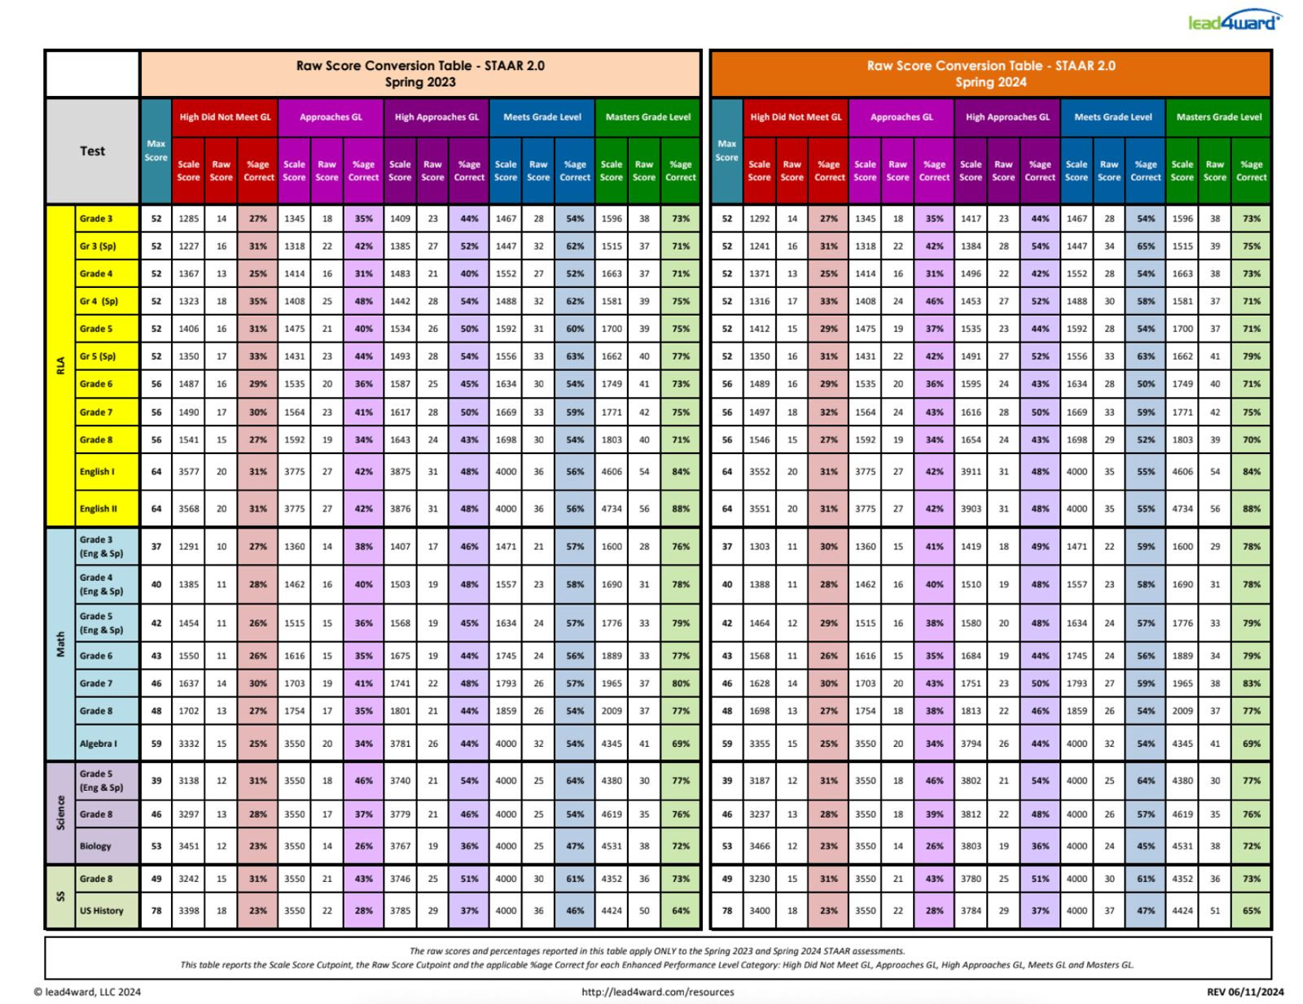
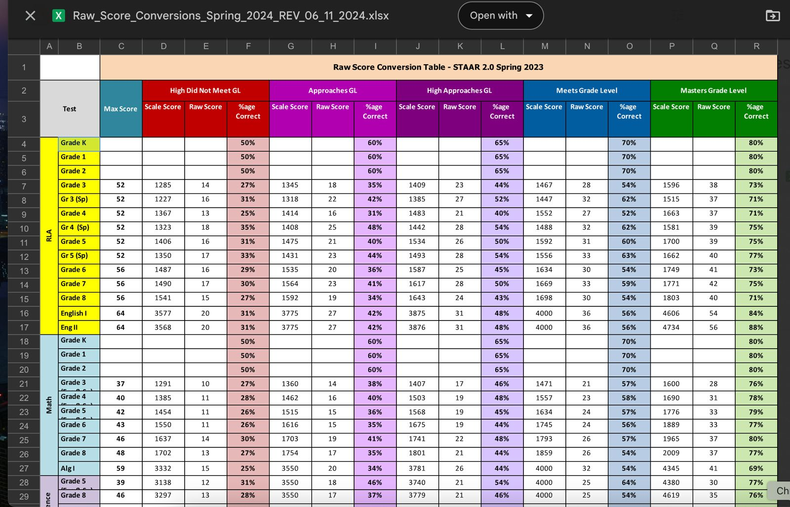

Campus/Academies Level Cut Points Grades.
- Staar Performance (Elem, Middle, HS) – Pre campus grade missing.
- CCMR only HS chart values will be used.
- Graduation Rate HS chart values will be used.
- Academic Growth (Elem, Middle, HS)
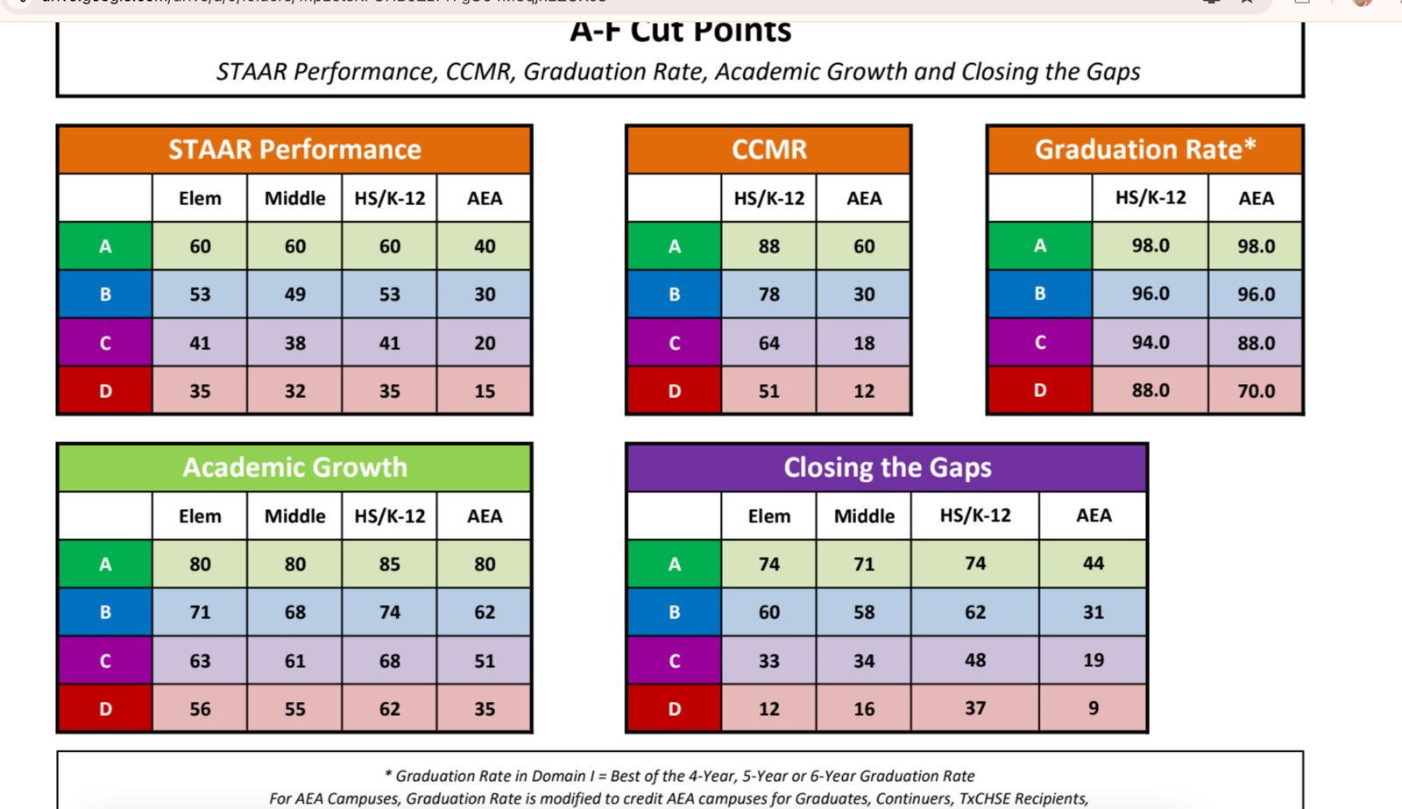
Student Level Growth Calculation chart
